NARENDRA MODI

*N*

*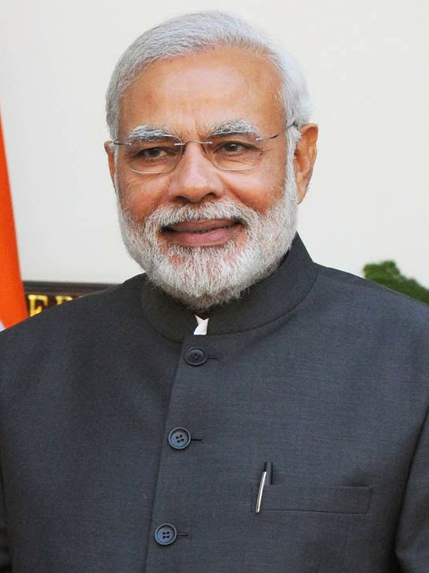arendar Modi, the current prime minister of India. His full name is Narendra Damodaran Modi. Narendra Modi is India’s 14th prime minister, serving since 2014. Born on September 17, 1950, in Vadnaga in northeastern Gujarat, where he completes his secondary education, he was introduced to RRS at the age eight. at the age of 18 he was married to Jashodaben Modi. Modi was the chief minister of Gujarat from 2001 to 2014 and the member of parliament for Varanasi. he is member of Bharti Janta party and of the Rashtriya Swayamsevak Sangh, a right wing Hindu nationalist paramilitary volunteer organisation. He is the longest-serving prime minister outside the Indian national congress.*

*After becoming the prime minister he also authored a book called Exam Warriors, a guide for children to commendably face exam. Modi has written eight other books, mostly containing short stories for children. Modi has penned the lyrics of two Gujarat garba songs; Garbo, sung by Dhvani bhanushali and comosed by tanishk bagchikand Maadi, sung by Divya kumar and composed by meet Bros. the songs were released on the occasion of autumn Navratri in 2023.*

*In the 2014 Indian general election, Modi led the BJP to a parliament majority, the first for a party since 1984. His administration increased direct foreign investment, and reduced spending on healthcare, education, and social welfare programmes. Modi began a high-profile sanitation campaign, controversially initiated a demonetisation of banknotes and introduced the goods and services Tax, and weakened or abolished environment and labour laws. Modi’s administration launched the 2019 Balakot airstrike against an alleged terrorist training camps in Pakistan.*